DATABASES:

Students:

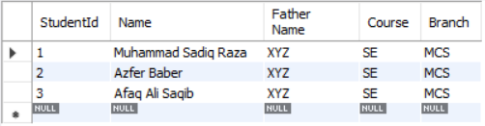

Books:

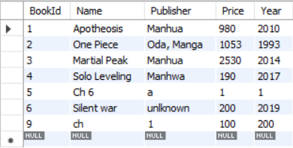

Issued Books:

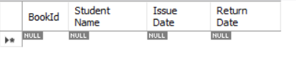

Books Requested to Issue:

